* NO smoking within 3 meters of doors and windows.
* NO smoking on decks or steps.
* NO smoking inside the units.

Strictly enforced as Housing Policy/By-law #_______

**Thank you for being considerate of your neighbours**

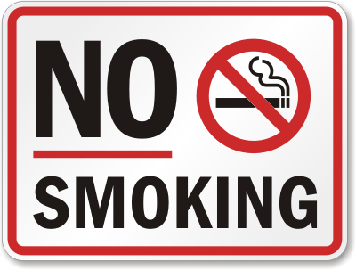

[This Photo](http://my-stylz.blogspot.com/2012/09/no-smoking.html) by Unknown Author is licensed under [CC BY-SA-NC](https://creativecommons.org/licenses/by-nc-sa/3.0/)